THEORY OF COMPUTATION-LAB

1.Write a C program to simulate a Deterministic Finite Automata (DFA) for the given language representing strings that start with a and end wit

PROGRAM:

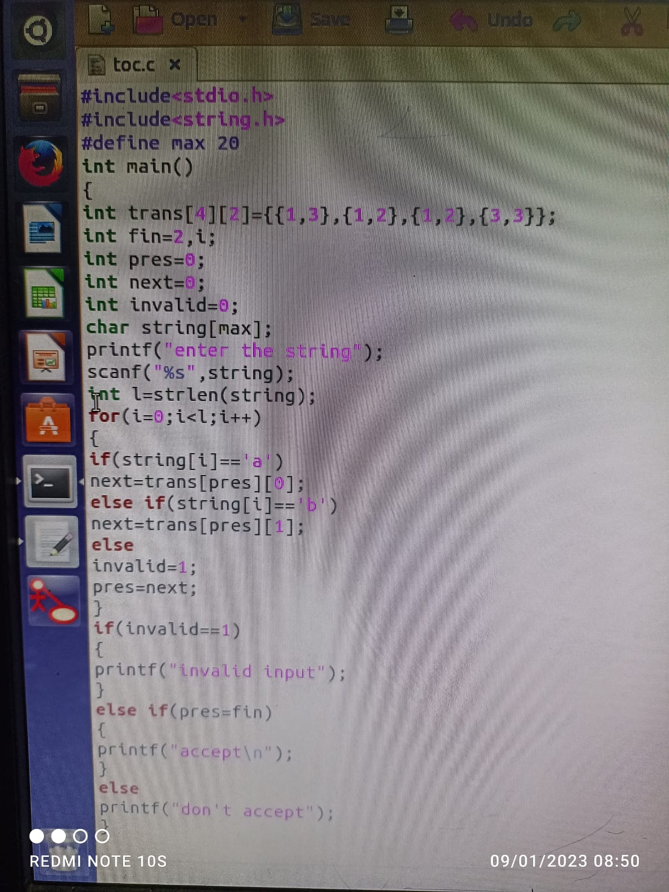



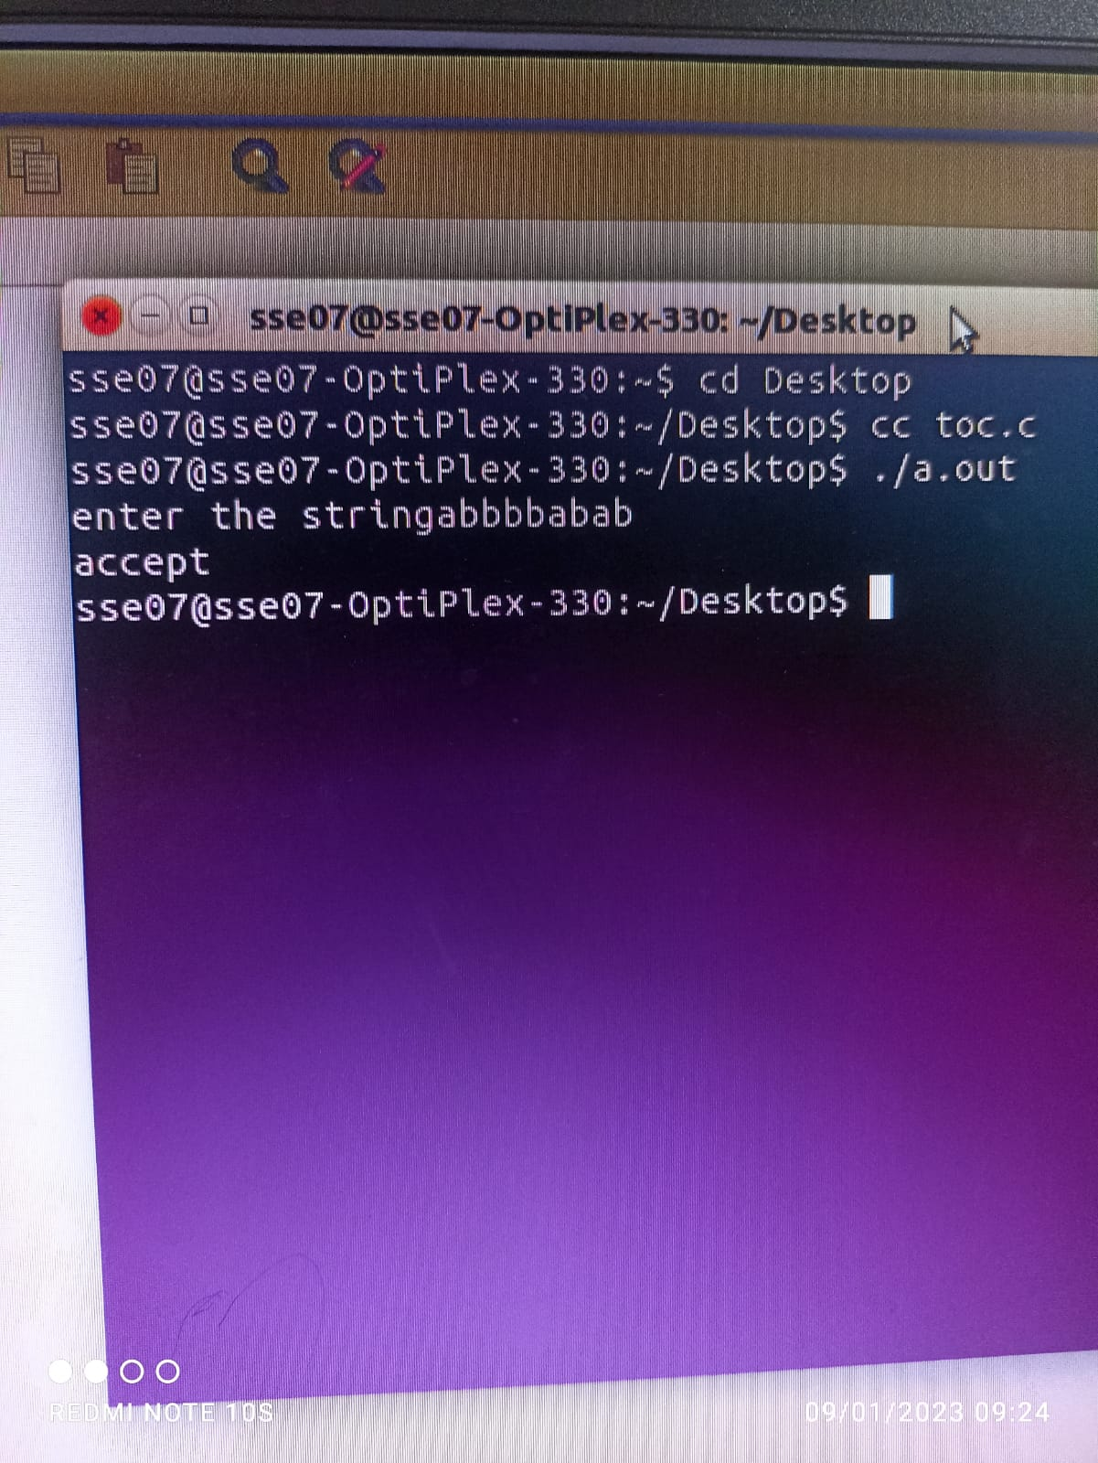

Write a C program to check whether a given string belongs to the language defined by a Context Free Grammar (CFG) S → 0A1 A → 0A | 1A | ε

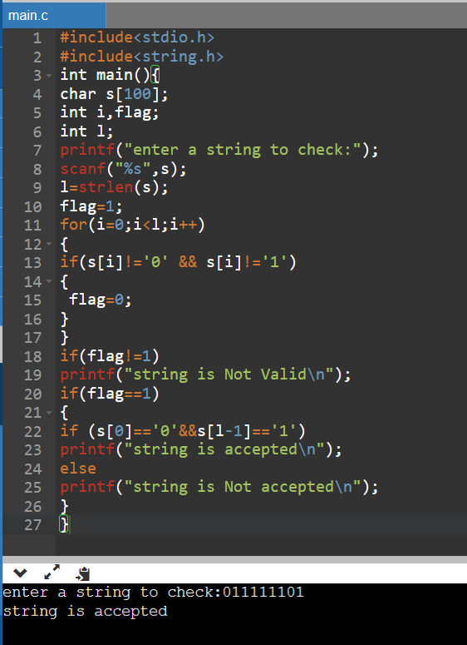

Write a C program to check whether a given string belongs to the language defined by a Context Free Grammar (CFG) S → 0S0 | 1S1 | 0 | 1 | ε

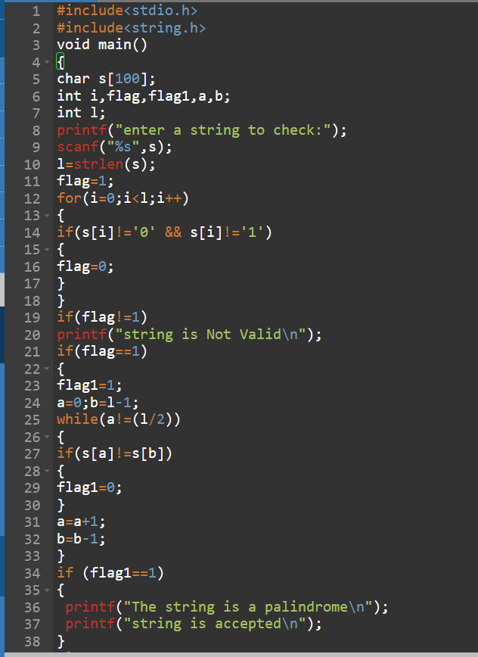

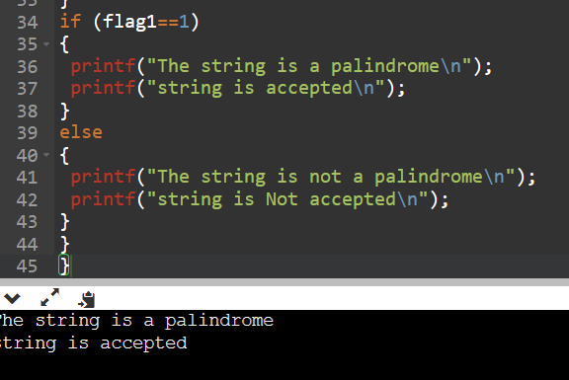

Write a C program to check whether a given string belongs to the language defined by a Context Free Grammar (CFG) S → 0S0 | A A → 1A | ε

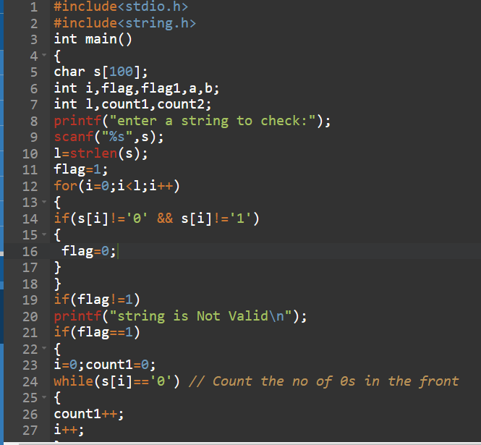

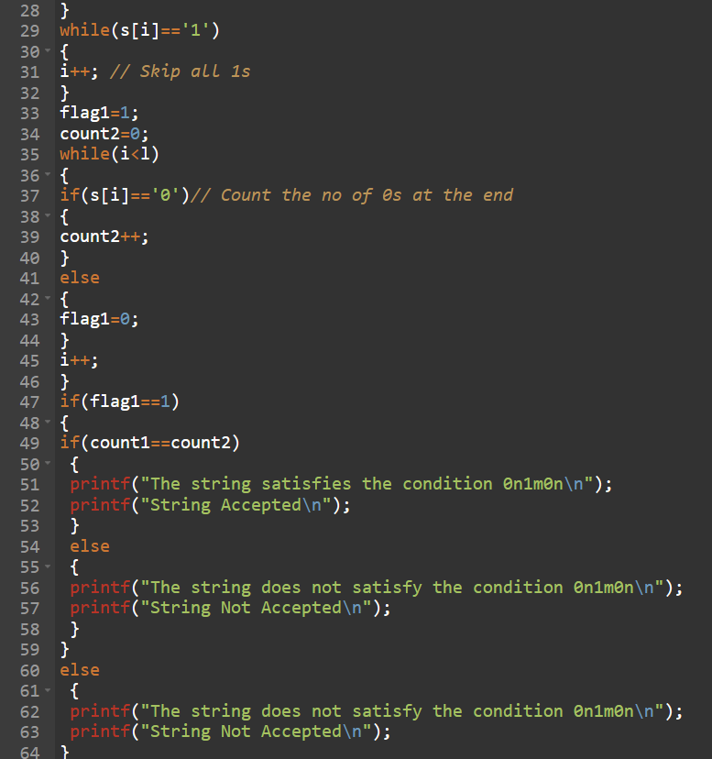

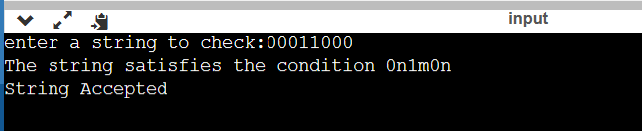

Write a C program to check whether a given string belongs to the language defined by a Context Free Grammar (CFG) S → 0S1 | ε

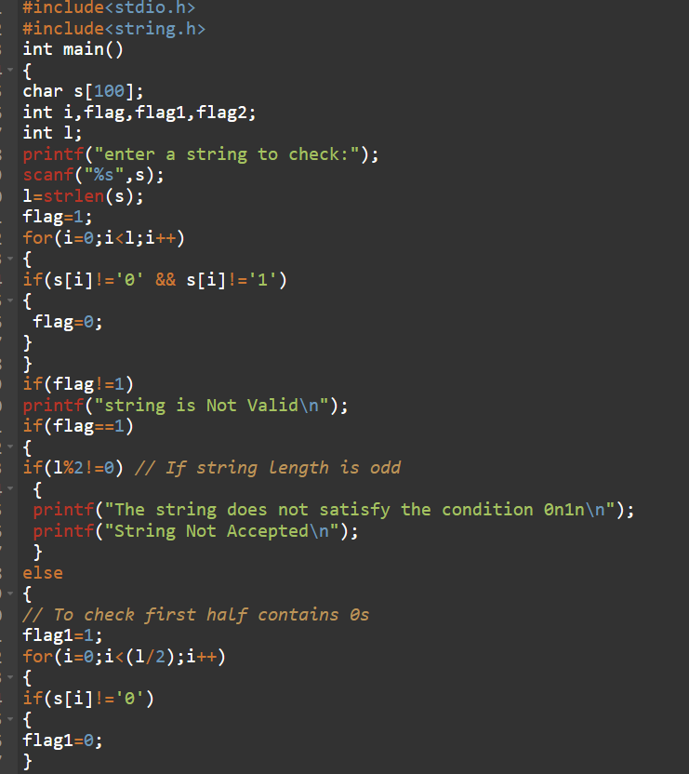

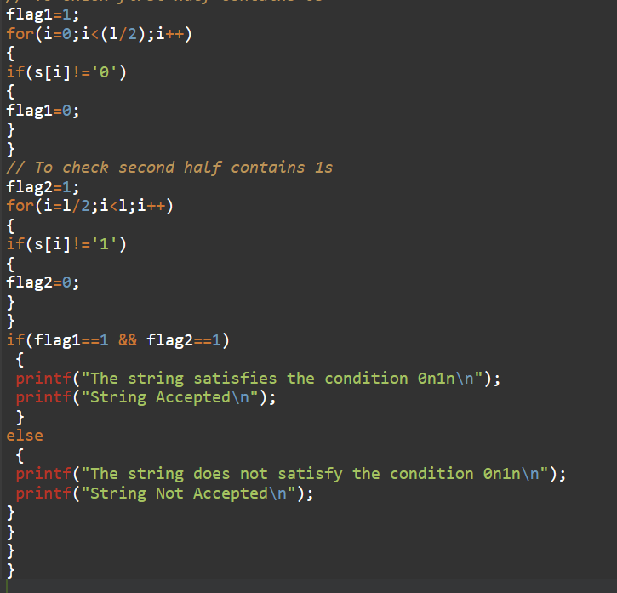

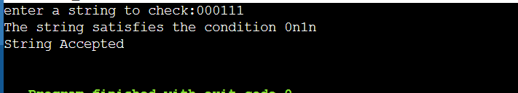

Write a C program to check whether a given string belongs to the language defined by a Context Free Grammar (CFG) S → A101A A → 0A | 1A | ε

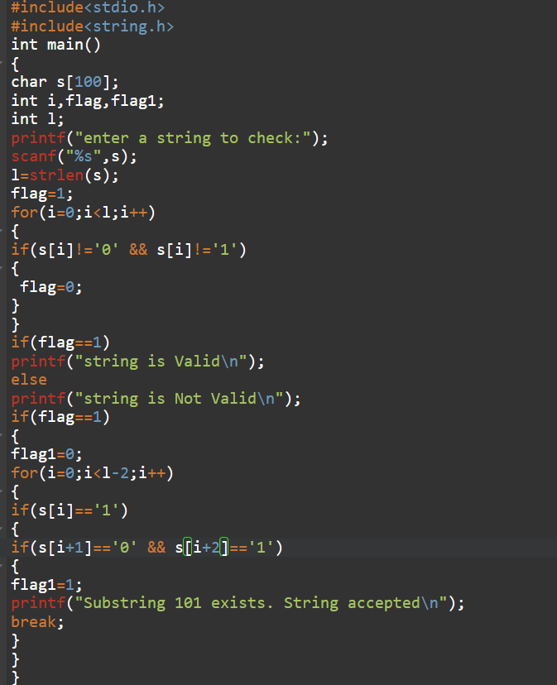

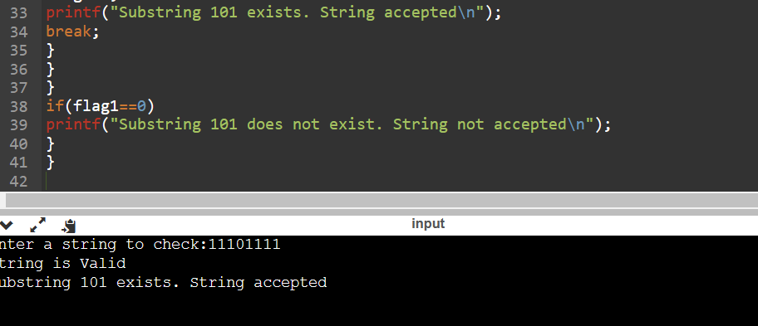

Write a C program to simulate a Non-Deterministic Finite Automata (NFA) for the

given language representing strings that start with o and end with 1

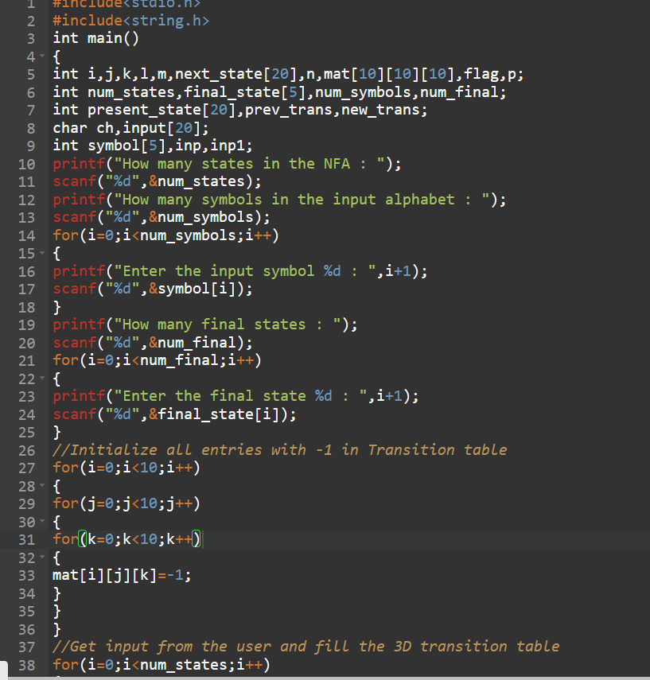

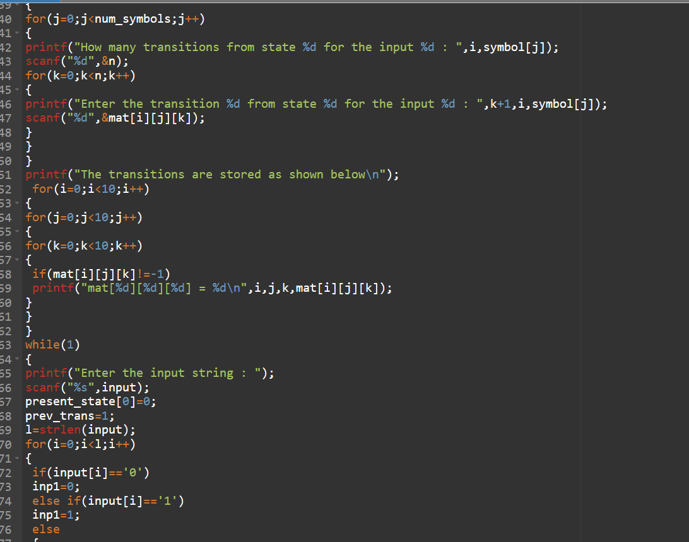

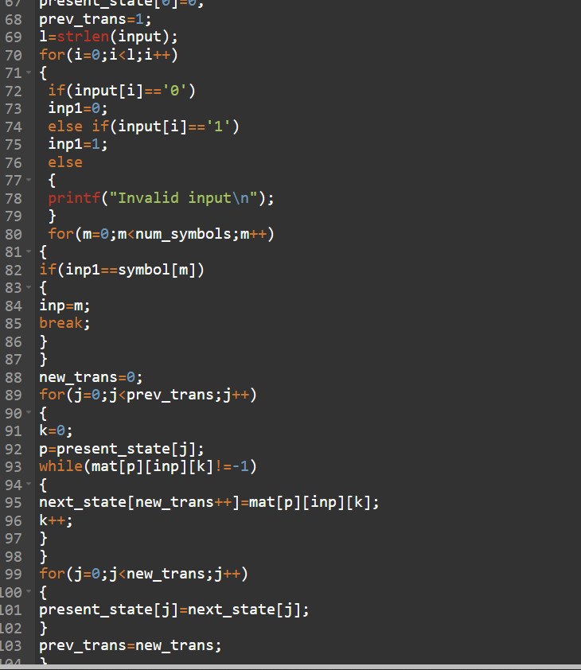

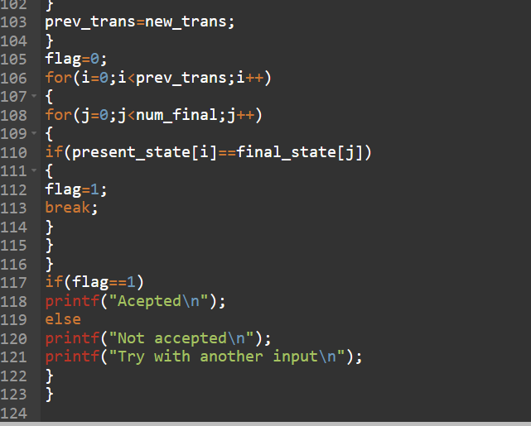

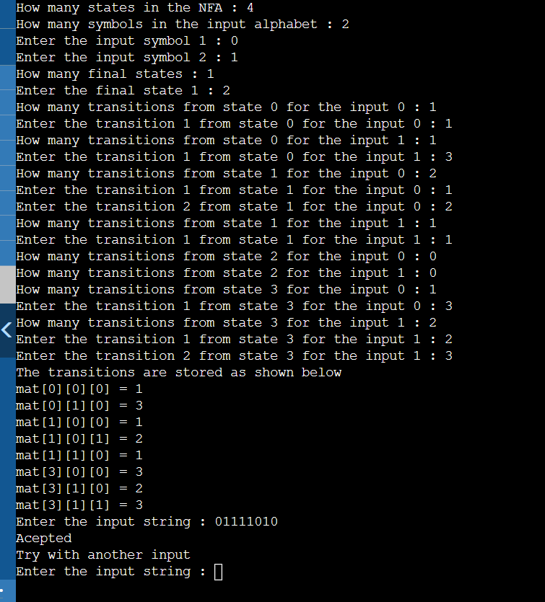

Write a C program to find ℇ-closure for all the states in a Non-Deterministic Finite Automata (NFA) with ℇ-moves.

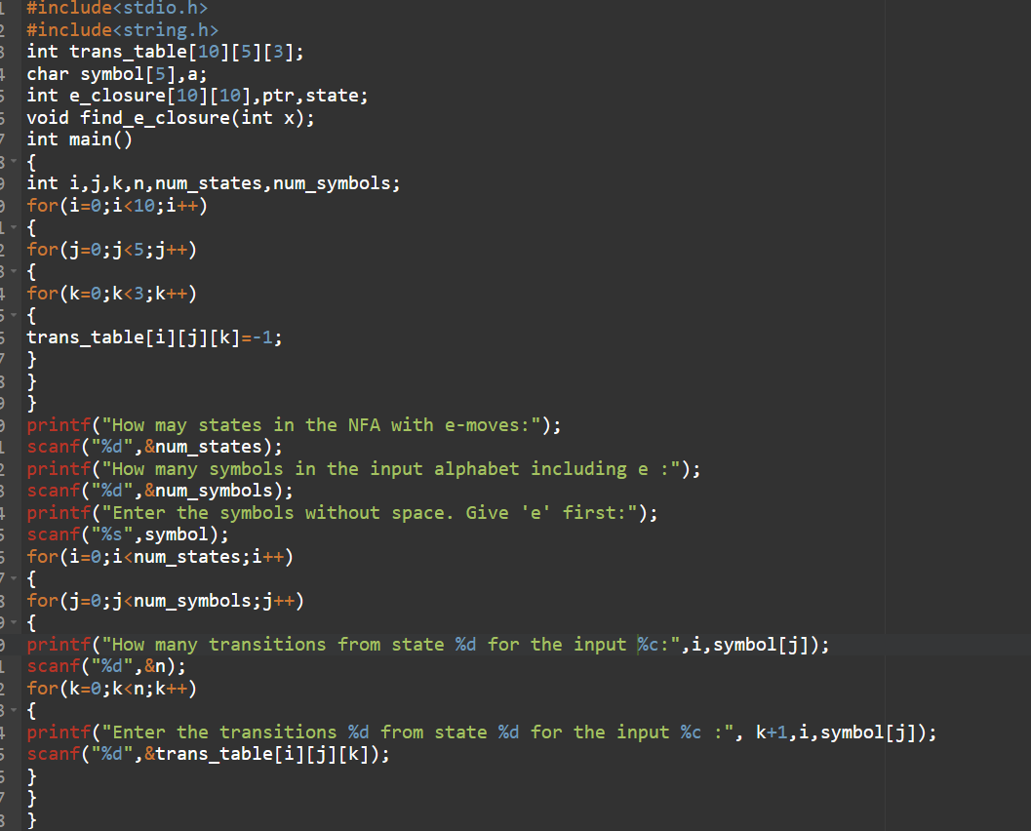

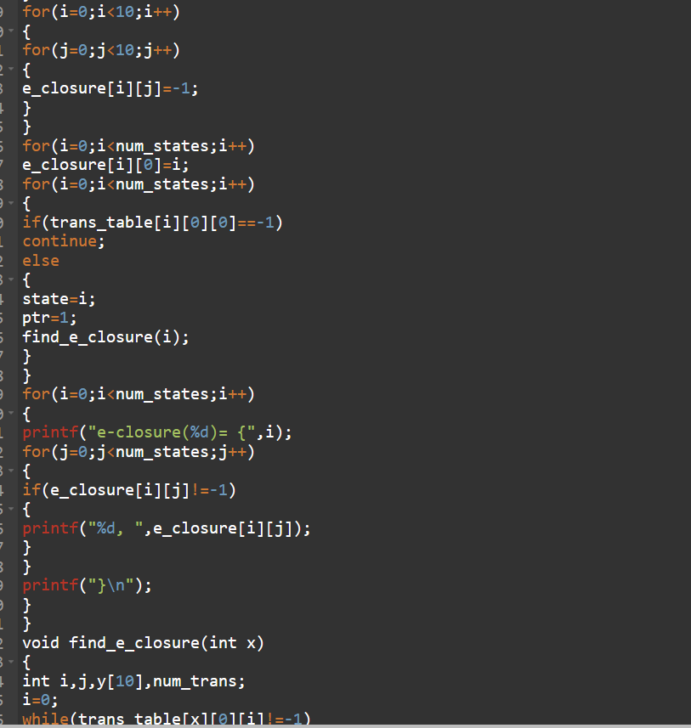

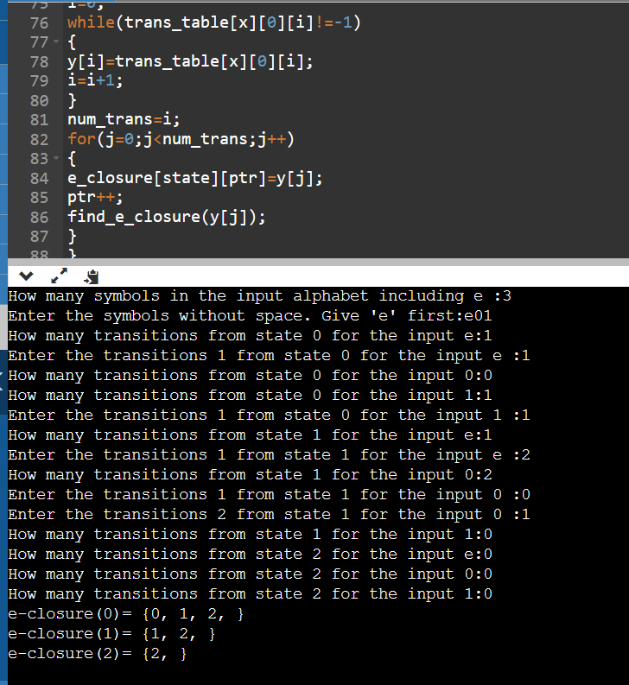

Design PDA using simulator to accept the input string aabb

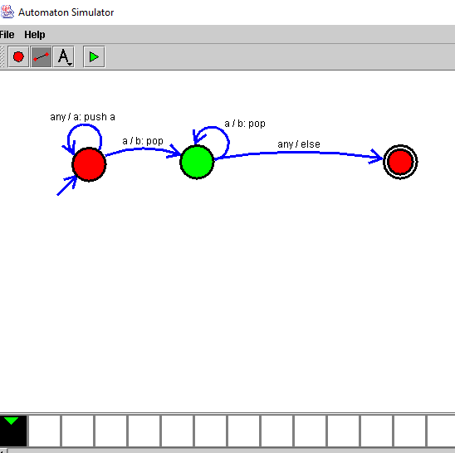

14. Design PDA using simulator to accept the input string a^nb^2n

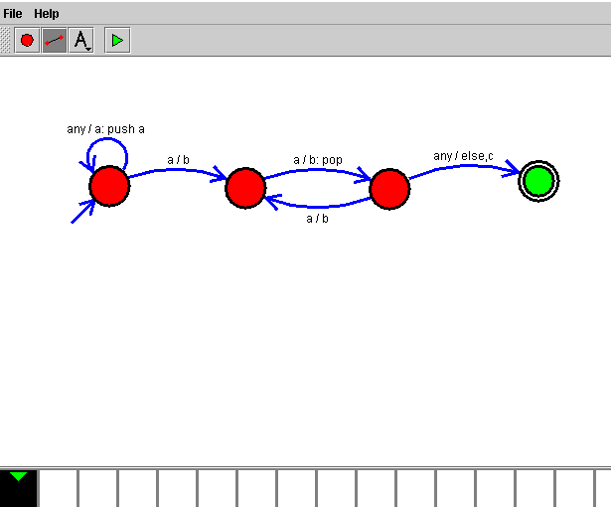

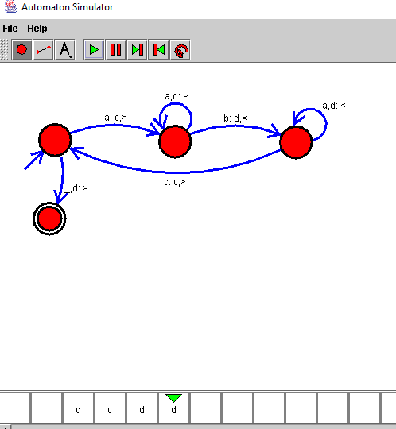

Design TM using simulator to accept the input string Palindrome ababa

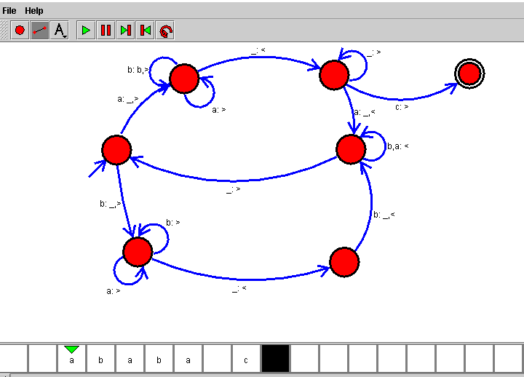

Design TM using simulator to perform addition of ‘aa’ and ‘aaa’

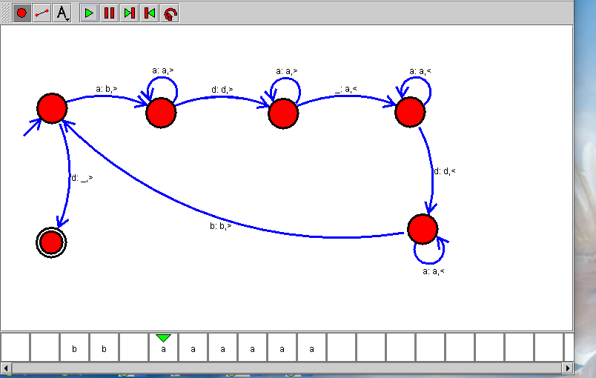

Design TM using simulator to perform subtraction of aaa-aa

